Chapter 3, Solution 70

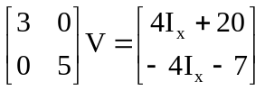

With two equations and three unknowns, we need a constraint equation,

I_{x} = 2V₁, thus the matrix equation becomes,

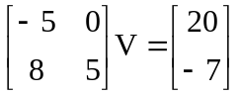

This results in V₁ = 20/(–5) = –4 V and
V₂ = [–8(–4) – 7]/5 = [32 – 7]/5 = 5 V.

